**LAB2: AIRLINE CONSORTIUM ASK**

**Directory Structure:**

**Level 1:**

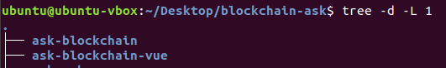

The Base directory consists of 2 main directories

1] Ask-blockchain : Contains all the blockchain related files like smart contracts, migration files etc.

2 ] Ask-blockchain-vue : Contain all the files related to the webapp developed in vue js

**Level 2:**

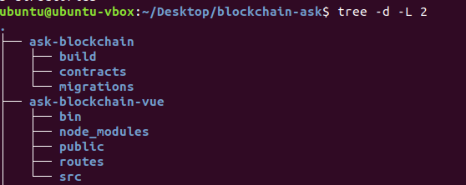

The folders contained in the 2 main directories is shown in the figure above.

**Folders and Files present in Ask-blockchain:**

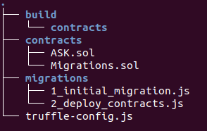

Contracts folder contains all the smart contract files. ASK.sol is the smart contract for ASK consortium and Migrations.sol is the contract used to deploy the smart contract.

**Folders and Files present in Ask-blockchain-vue:**

The src folder consists of all the import frontend related files. Components , views and Util are a few of important directories.

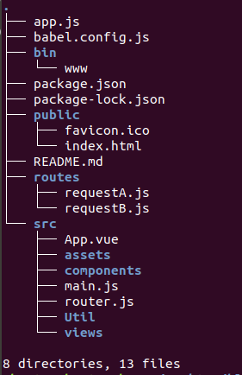

**Steps to Execute:**

**Step 1:- Compile and deploy the contracts using truffle**

1] Go to directory /home/ubuntu/Desktop/blockchain-ask/ask-blockchain and then type ***truffle compile***

2] Then once its done type ***truffle migrate –Reset***.

**Step 2:- Compile and deploy the web app**

3] In New terminal Go to directory /home/ubuntu/Desktop/blockchain-ask/ask-blockchain-vue and then type ***npm install*** to install all the dependencies.

4] Then once its done type ***npm start***. To connect to database. If successful “Connected to database is received”

5] In New terminal Go to directory /home/ubuntu/Desktop/blockchain-ask/ask-blockchain-vue and then type ***npm run serve*** to start app.

6] The local host link will be visible on the page.

7] 3 main pages are there:-

7.1] Admin page where we unregister airlines. ID:- SU PWD:- anything

7.2] Airline page where airlines accept or deny requests ID:- airline PWD:- airline

7.3] User page where users request for change in flights.

Airline A ID:- thanos PWD:- thanos

Airline B ID:- stark PWD:- stark